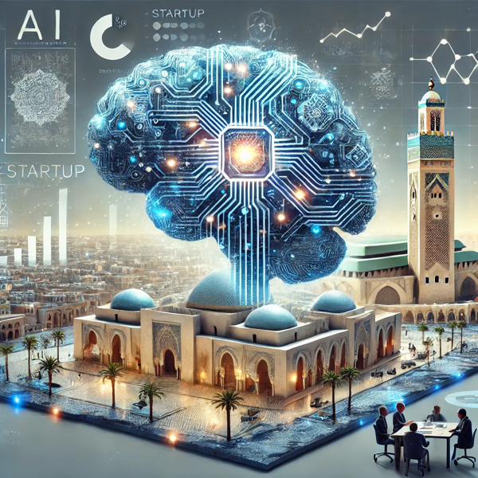

M

**MentorStartAi**

Realised by :

Belahcen Nada

Cherqi Aya

Senhaji Kaoutar

|  |
| --- |
| Introduction |

In recent years, entrepreneurship has become a vital driver of economic growth and innovation. However, for many aspiring entrepreneurs, the process of starting a business can be overwhelming, especially when it involves navigating complex legal frameworks, understanding market dynamics, and developing a solid business model.

To address these challenges, we have developed an **AI and NoSQL-based platform** that provides personalized assistance to users seeking to create their own startups. The platform utilizes state-of-the-art AI technology to answer questions related to the various steps of startup creation and the laws applicable in Morocco. By integrating real-world examples of successful startups and offering localized advice, the system serves as a comprehensive guide for entrepreneurs at any stage of their journey.

This project bridges the gap between accessibility and knowledge, enabling users to approach entrepreneurship with confidence and clarity.

Table des matières

1

Introduction 1

Objectifs 3

• 1. Provide Step-by-Step Guidance 3

• 2. Deliver Localized Legal Advice 3

• 3. Present Practical Examples: 3

• 4. Leverage AI to Answer Queries 3

• 5. Enhance Accessibility 3

Tools used 3

Structure of the project 5

1. Frontend Module 5

2. Backend Module 5

3. AI Module 6

4. Deployment and Integration 6

web scraping 6

tests of the project 8

conclusion 9

|  |
| --- |
| Objectifs |

The main objective of this project is to create an intelligent system that simplifies the process of starting a business. The platform is designed to:

* 1. Provide Step-by-Step Guidance: Help users understand the key steps involved in establishing a startup, from ideation to execution.
* 2. Deliver Localized Legal Advice: Offer insights into the legal procedures and requirements specific to Morocco, ensuring compliance with national regulations.
* 3. Present Practical Examples: Use a database of startup examples to inspire and guide users based on proven business models.
* 4. Leverage AI to Answer Queries: Enable users to ask any question related to startups and receive accurate, tailored answers.
* 5. Enhance Accessibility: Ensure that even individuals with limited technical or entrepreneurial knowledge can easily use the platform.

|  |
| --- |
| Tools used |

The success of this project relies on a robust combination of tools and technologies, ensuring functionality, scalability, and user-friendliness:

**Backend**

• **Pinecone**:

• Used to manage and retrieve information using embeddings. This ensures that the system can process user queries and retrieve the most relevant data about startup creation steps and legal requirements in Morocco.

• **MongoDB & MongoDB Atlas**:

• Serve as the primary NoSQL database systems. These are used to store real-world examples of startups, making them easily accessible for reference.

* **Web scraping**

It was used to collect real-world startup examples from reliable online sources. The extracted data was stored in MongoDB to provide diverse and relevant references for users seeking inspiration and guidance on startup creation :

**Frontend**

• **Flask**:

• A lightweight Python-based web framework that powers the platform’s backend and integrates with the AI model and database.

• **HTML, Bootstrap, and JavaScript**:

• Used to design a dynamic, responsive, and user-friendly interface. These technologies ensure that users can interact smoothly with the system and receive real-time feedback.

**AI Model**

• **Gemini**:

• A pre-trained AI model that processes user queries, interprets their intent, and provides accurate responses. Its advanced natural language processing (NLP) capabilities allow the system to understand and address complex questions effectively.

|  |
| --- |
| Structure of the project |

The project follows a modular structure to ensure maintainability and scalability.

### 1. Frontend Module

The frontend provides a seamless and interactive user interface where users can:

• Submit questions about starting a business.

• View step-by-step guidance and legal procedures.

• Access examples of existing startups.

The interface is built using HTML and styled with Bootstrap for a modern look and feel, while JavaScript handles dynamic content and interactivity.

### 2. Backend Module

The backend is the core of the system, handling:

• **Query Processing**: Flask connects the frontend with the AI model and the database.

• **Data Retrieval**: Pinecone fetches relevant information using embeddings, ensuring accurate answers to user queries.

• **Database Management**: MongoDB and MongoDB Atlas store and manage structured data, including startup examples.

### 3. AI Module

The AI module uses Gemini to process natural language queries, identify user needs, and deliver precise answers. It works in conjunction with Pinecone to retrieve embedded data related to startup creation and Moroccan laws.

### 4. Deployment and Integration

The entire system is deployed on a secure server, making it accessible to users. The integration of all modules ensures smooth communication between the frontend, backend, and AI components.

|  |
| --- |
| web scraping |

It was used to collect real-world startup examples from reliable online sources. The extracted data was stored in MongoDB to provide diverse and relevant references for users seeking inspiration and guidance on startup creation :

|  |
| --- |
| tests of the project |

À remplir

|  |
| --- |
| conclusion |

This project demonstrates how cutting-edge technologies can be combined to create a powerful tool for aspiring entrepreneurs. By integrating AI with NoSQL databases, the platform provides a unique blend of personalized guidance, practical examples, and localized legal advice.

The focus on Morocco ensures that the system addresses the specific needs of users in the region, making it an invaluable resource for fostering entrepreneurship and innovation. With its scalable architecture and user-friendly design, the platform has the potential to expand its reach and support entrepreneurs worldwide, ultimately contributing to the global startup ecosystem.